Beware the Overly Charismatic Leader

Charisma can be a tricky thing. Leaders who do not possess enough charisma often fail to inspire others to rally around the cause, particularly when they are managing larger groups or supervising complex tasks. On the other hand, there are many individuals who possess the ability to lead with quiet, humble confidence. While we might not see this type of leader as “charismatic”, people are still drawn to trust and follow her or him.

Studies (and probably your own experience) demonstrate that too much charisma can be damaging in a leader. Individuals who you might classify as “overly charismatic” tend to describe themselves as talkative, inventive, energetic, and original. They also describe themselves as good-looking, persevering, and ingenious. Others describe these “charismatic” individuals as talkative, energetic, and original, but not as good looking and persevering. This indicates that charismatic individuals have inflated views of themselves which are inconsistent with how other people see them.

In recent years, researchers have examined the relationship between charisma and overall effectiveness in a study of over 300 business leaders.

They found that there was a significant curvilinear relationship between charisma scores and coworker-rated effectiveness (below).

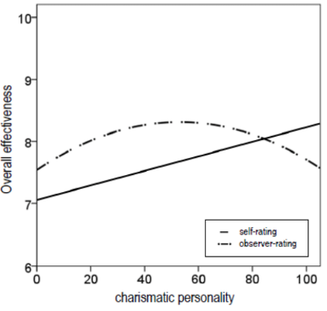
According to coworkers, some degree of charisma – neither too little nor too much – predicted the highest levels of effectiveness.

Coworkers indicated that those managers with scores slightly above the average in a large sample of working adults (60th percentile) were the most effective leaders. After that, more charisma predicted decreasing effectiveness.

At about the 70th percentile, coworkers start to see the dark side of charisma—where confidence becomes arrogance and a disregard for other ideas or alternatives, risk-taking gets reckless as the dull operational processes grow less important than the leader’s personal vision, social presence appears melodramatic, and strong vision becomes ungrounded grandiosity.

Unfortunately, these highly charismatic leaders can’t see the downside, and in fact see themselves as extraordinarily effective.

Leaders with just the right amount of charisma, neither too little nor too much, are the most effective. Some charisma generally is desirable; without any spark, leaders lack the confidence, charm, vision, and flair needed to inspire others. But when it comes to charisma, there is clearly such a thing as too much of a good thing: we also need leaders who are down to earth, receptive to feedback, and humble.

Key HR Takeaways:
- Organizations need to be wary of potential leaders who show too much charisma. While they excel at grabbing the attention of senior leaders, they tend to be all bluster and no substance. At the same time, organizations need to make a concerted effort to identify potential leaders who show more humility. Such individuals are often overlooked in favor of the more pompous charismatics, but employees of humble leaders are more engaged, satisfied, and productive.
- Leadership development strategies need to bring highly charismatic leaders back to reality. Coworker feedback is obviously one way to help charismatics calibrate their excessively rosy self-appraisals.
- Charismatic leaders can also benefit from working with a partner who provides a practical foil to their unrealistic self-beliefs. Such a person needs to be trusted by the larger-than-life charismatic; they need the insight not to be taken in by the charismatic’s charm, and they need to be able to steer charismatic leaders back on track—and prevent them from going over the edge.
- Sometimes our strengths (e.g., the ability to inspire and motivate others) can be weaknesses when we overdo them or rely on them too much. The most effective leaders are trustworthy, competent and good-decision makers, but are also capable of setting a vision for the team without overdoing it.

Source: The double-edged sword of leader charisma. Journal of Personality & Social Psychology 2018

Written by a Catapult Advisor.

